DNS Resolver and Query Analyzer
Submitted By
IZAAN MUJEEB
22K-4635
ANAS SHOAIB
22K-4592

1. Motivation
The increasing reliance on the internet for real-time applications has made DNS performance and reliability more critical than ever. The DNS Resolver and Query Analyzer project was inspired by the need to enhance transparency and efficiency in DNS operations, enabling users to trace and analyze DNS resolution paths and improve debugging and optimization efforts.

2. Overview

2.1 Significance of the Project
The project aims to shed light on one of the most fundamental services in networking—the Domain Name System (DNS). Although DNS operates behind the scenes, its role in converting domain names into IP addresses is critical. Analyzing how DNS resolution works and providing tools to trace and diagnose DNS queries helps developers, network engineers, and students understand latency, failures, and misconfigurations. The tool offers academic value by demystifying complex DNS interactions and practical value in real-world network troubleshooting.

2.2 Description of the Project
The DNS Resolver and Query Analyzer simulates the process of DNS resolution by manually resolving domain names through iterative queries to root, TLD, and authoritative name servers. It provides a step-by-step analysis of how a domain is resolved and presents statistics such as time taken, server addresses, and the number of hops. The tool is designed for educational use and real-time analysis of DNS behavior, with a focus on transparency and traceability.

2.3 Background of the Project
The Domain Name System (DNS) is a decentralized naming system used by devices, services, and applications connected to the internet or a private network. The standard DNS resolution process involves several server types, including recursive, root, TLD, and authoritative name servers. Existing tools like dig or nslookup provide raw data, but this project focuses on visualizing and analyzing the entire resolution path. Key references include:
[1] Mockapetris, P. (1987). RFC 1035 - Domain Names - Implementation and Specification.
[2] Albitz, P., & Liu, C. (2001). DNS and BIND. O'Reilly Media.
[3] IETF RFCs and DNS documentation: https://www.ietf.org/standards/

2.4 Project Category
This project falls under the Research-based category, as it involves simulation, analysis, and development of custom solutions to visualize and understand DNS mechanisms.

3. Features / Scope / Modules
- 1. Manual DNS Resolution Simulation
Simulates DNS resolution by querying each layer of the DNS hierarchy (root, TLD, authoritative).
- 2. Query Trace Visualization
Tracks and displays each hop in the DNS resolution path for a given domain.
- 3. Latency Analysis
Measures and presents time taken at each resolution step to help diagnose delays.
- 4. Error Detection and Handling
Captures and interprets various DNS resolution errors such as NXDOMAIN, SERVFAIL, etc.
- 5. Flexible Domain Input and Configuration
Allows custom domain entries and DNS server configuration for advanced analysis.
- 6. Graphic Visualization Of Comparisons
Provides detailed step-by-step logging of DNS resolution process.

4. Project Planning
The project was divided into phases:
- Phase 1: Research on DNS resolution mechanism.
- Phase 2: Designing the simulation logic and planning module interactions.
- Phase 3: Implementation of resolver and analysis components.
- Phase 4: Testing and debugging.
- Phase 5: Final reporting and presentation.
Each team member contributed equally to research, coding, and documentation, with designated roles in development and testing.

5. Project Feasibility
Technical Feasibility
Is your project possible with current technology, what are the technical risks involved in your project etc.
The project is technically feasible using Python sockets and DNS query libraries. No proprietary systems are required. Network-level packet capturing was avoided for simplicity and security.
Economic Feasibility
Is your project possible given resources constraints, what are its benefits, what are its development and operational costs etc?
The solution is open-source and developed using freely available tools. No additional hardware or commercial software licenses are needed.
Schedule Feasibility
Is your project being completed in a given time frame, any time constraints for the project etc?
The timeline set during planning was met, and the complete project was developed within the academic semester without delays.

6. Hardware and Software Requirements
Hardware
- Standard PC/Laptop with internet access
- Minimum 4GB RAM
Software
- Operating System: Windows/Linux
- Programming Language: Python 3.x
- Libraries: socket, dnspython, time, argparse
- IDE: VS Code / PyCharm / Google Colab

7. Diagrammatic Representation of the Overall System
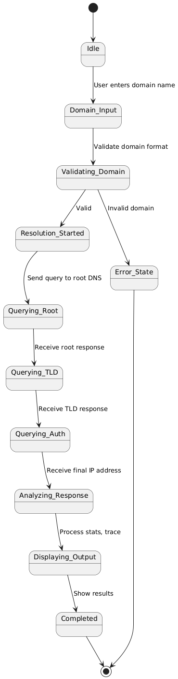

8. References
[1] Mockapetris, P., “RFC 1035 - Domain Names - Implementation and Specification”, IETF, 1987.
[2] Albitz, P., Liu, C., DNS and BIND, O'Reilly Media, 5th Edition, 2006.
[3] DNS Reference Documentation, IETF, https://www.ietf.org/standards/

